## -:ACKNOWLEDGEMENT:-

##### We take this opportunity to humbly express our thankfulness to all those concerned with our project.

First of all we are thankful to **LDRP - ITR** for undertaking this project. We are sincerely indebted to  **MR . SHRIKANT PATEL** for giving us the opportunity to work on this project. Her continuous guidance and help have proved to be a key to our success in overcoming the challenges that we have faced during our project work. Her support made the project a pleasantly memorable one .Without her help at all stages in spite of her own work load; the completion of the project would not have been possible.

##### We express our sincere gratitude to **Dr. SANDIP MODHA** for his valuable guidance and positive feedback.

There are so many persons without whose help we would never have conceived and learnt , to whom we would like to express my gratitude – my friends , colleagues, and of course CE & IT Department of LDRP ITR.

##### Last but not least we are thankful to almighty GOD and our PARENTS for giving us such a good atmosphere to work hard and to succeed.

**With regards**, Patel Dev V

Patel Akash Parmar Arjun Patel Femin

-:INDEX:-

**1) Introduction………………………………………………………..**

* **Project Profile**
* **Project Summary**
* **Project Purpose**
* **Project Goals**
* **Project Scope**

1. **System Requirement Study……………………………………….**
   * **User Characteristics**
   * **Hardware Requirements**
   * **Software Requirements**

**3) Tools and Technology……………………………………………...**

* + **Technology Study**
  + **Feasibility Study**

1. **System Analysis and Design ………………………………………**
   * **UseCase Diagram**
   * **Class Diagram**
   * **Activity Diagram**

**5) Screen Shots ……………………………………………**

**6) Conclusion ……………………………………………...**

* + **Advantages**
  + **Limitations**
  + **Conclusions**

**7) Bibliography……………………………………………...**

## -:PREFACE:-

* Project during the study is the bridge between the theoretical and practical knowledge. The main objective of the project is to get details about the operation process being carried out within the company. Theory of any subject is important but without its practical knowledge, it becomes useless.
* Practical training polishes the theoretical aspects of the technical studies. The aim is to open up the window of project knowledge to a student and give hint of an insight regarding the operations, processes and trouble shooting of a system.

###### Objectives of Report

* To develop a system, this can be used for managing the entire data in a an efficient manner.
* To provide a system that puts the whole system in a single platform.
* To design a system that will have good interface and well documented user guide.
* To understand and enforce the importance of project management aspects, during the software development.
* To develop a system this can be use for current as well as future aspects of Indian business for the marketing.

# Introduction

* + **Project Profile**
  + **Project Summary**
  + **Project Purpose**
  + **Project Goals**
  + **Project Scope**



## -:PROJECT PROFILE:-

|  |  |
| --- | --- |
| **Project Title :** | **HILL CLIMB RACING GAME AUTOMATION** |
| **Organization :** | **LDRP INSTITUTE OF TECHNOLOGY AND RESEARCH** |
| **Tools :** | **Hardware**   * PROCESSOR – INTEL CORE i3 * RAM – 4GB RAM * HARD DISK – 1 GB HDD * LCD MONITOR   **Software**   * OPERATING SYSTEM – WINDOWS 10 * PLATFORM – Python |
| **Starting Date :** | 31/05/2022 |
| **Ending Date :** | 25/07/2022 |
| **Team Size :** | 4 person |
| **Team Members:** | PATEL DEV V  PATEL AKASH |

|  |  |
| --- | --- |
|  | PATEL FEMIN  PARMAR ARJUN |
| **Guided By :** | PROF. SHRIKANT PATEL  Lecturer (CE - IT Dept.) |
| **Submitted To:** | DEPARTMENT OF COMPUTER ENGINEERING& INFORMATION TECHNOLOGY,  LDRP INSTITUTE OF TECHNOLOGY & RESEARCH, GANDHINAGAR |

#### -:PROJECT SUMMARY:-

* The objective of Hill Climb Racing is to drive as far through progressively difficult racing stages as possible while collecting coins, taking advantage of the nonrealistic physics and using only two simple controls: the Gas and Brake pedals. While in midair, pressing these pedals will instead cause the vehicle to rotate, allowing the player to control the angle with which they land. Fuel is replenished by picking up gas canisters or batteries along the way. The player can perform stunts such as driving the vehicle into the air for a prolonged time or flipping it over to earn more coins, which after the race may be spent on upgrades or to unlock new stages and vehicles (including monster trucks, dirt bikes, tanks, and Santa's sleigh). Conditions ending the game are depleting the vehicle's fuel or hitting the driving avatar's head.: 271
* Since its inception, Hill Climb Racing has seen updates that add new content. For example, the garage was introduced in a December 2016 update, where players can purchase cars and tune their parts. Gems were also introduced as a currency of the game.

#### -:PROJECT PURPOSE:-

* Hill Climbing is a heuristic search used for mathematical optimisation problems in the field of Artificial Intelligence. So, given a large set of inputs and a good heuristic function, the algorithm tries to find the best possible solution to the problem in the most reasonable time period. This solution may not be the absolute best (global optimal maximum) but it is sufficiently good considering the time allotted. The definition above implies that hill-climbing solves the problems where we need to maximise or minimise a given real function by selecting values from the given inputs. A great example of this is the Travelling Salesman Problem where we need to minimise the distance travelled by the salesman.

#### -:PROJECT GOALS:-

* + This project is main goal at developing a complete game Automation system for use in the game industry.
  + This project is used to automate all process of the hill climb racing game.

#### -:PROJECT SCOPE:-

* This project will be helpful to kids, adults, working women as well as mediocre people. It is helpful to the kids to watch cartoons for the revision of their studies. Similarly, for adults, it helps in learning new skills by video content in different languages. For working women, it helps to learn how to manage times and some cooking content. It entertains you more than any other platform. The ordinary man can have a good review by watching trending on Youtube.

1. **System Requirement Study**

* **User Characteristics**
* **Hardware Requirement**
* **Software Requirement**

#### -:USER CHARACTERISTICS:-

* + Our project is the Gaming App, is site can be used to automate all process of the hill climb racing game. This is used to play automate game.

#### -:HARDWARE REQUIREMENT:-

* + As we are preparing a computerized system, obviously the most basic hardware need of the system is a computer. The minimum requirement is as follows.
    - PROCESSOR – INTEL CORE i3
    - RAM – 4GB RAM
    - HARD DISK – 1 GB HDD
    - LCD MONITOR

#### -:SOFTWARE REQUIREMENT:-

* + - OPERATING SYSTEM – WINDOWS 10
    - PLATFORM – Python

# Tools & Technology

* + **Technology study**
  + **Feasibility Study**

### PYTHON:

##### There are mainly two Python library we have used in the gaming application.They are Numpy and OpenCv .

* OpenCV is the huge open-source library for the computer vision, machine learning, and image processing and now it plays a major role in real-time operation which is very important in today’s systems. By using it, one can process images and videos

to identify objects, faces, or even handwriting of a human. When it integrated with various libraries, such as NumPy, python is capable of processing the OpenCV array structure for analysis. To Identify image pattern and its various features we use vector space and perform mathematical operations on these features

* The first OpenCV version was 1.0. OpenCV is released under a BSD license and hence it’s free for both **academic** and **commercial** use. It has C++, C, Python and Java interfaces and supports Windows, Linux, Mac OS, iOS and Android. When OpenCV was designed the main focus was real-time applications for computational efficiency. All things are written in optimized C/C++ to take advantage of multi-core processing.

NumPy is a general-purpose array-processing package. It provides a high-performan- ce multidimensional array object, and tools for working with these arrays. It is the fundamental package for scientific computing with Python. It contains various features including these important ones:

* A powerful N-dimensional array object
* Sophisticated (broadcasting) functions
* Tools for integrating C/C++ and Fortran code
* Useful linear algebra, Fourier transform, and random number capabilities

### Feasibility Study:-

In the conduct of the feasibility study, we consider seven distinct, but inter-related types of feasibility .They are:-

1. Technical feasibility
2. Operational feasibility
3. Economic feasibility
4. Social feasibility
5. Management feasibility
6. Legal feasibility
7. Time feasibility

###### TECHNICAL FEASIBILITY

This is concerned with specifying and software that will successful satisfy the user requirement the technical needs of the system may vary considerably, but might include:

* The facility to produce outputs in given time.
* Response time under certain conditions.
* Ability to process a certain volume of tasks at a particular speed.
* Facility to communicate data to distant location

In examining technical feasibility, configuration of the system is given more importance than the actual make of hardware .The configuration should give the complete picture about the system’s requirements:-

At the feasibility stages, it is desirable that two or three different configuration will be pursued that satisfy the key technical requirement but which represent different levels of ambition and cost. Investigation of these technical alternatives can be aided by approaching a range of supplies for preliminary discussion out of all types of feasibility. Technical feasibility generally is the most difficult to determine.

###### OPERATIONAL FEASIBILITY

It is mainly related to human organizational and political aspects .The points to be considered are:

1. What change will be brought with the system?
2. What organizational structures are distributed?
3. What new skills will be required? Do the existing staff members have these skills?
4. If not, can they be trained in due course of time?

Generally Project will not be rejected simply because of Operational infeasibility but such consideration is likely to critically affect the nature and scope of the eventual recommendation. This feasibility study is carried out by a small group of people who are familiar with information system techniques who understand the parts of the business that are relevant to the project and are skilled in system analysis and design process.

###### ECONOMIC FEASIBILITY

Economic analysis is the most frequently used technique for evaluation the effectiveness of a proposed system. More commonly known as Cost/benefits analysis: the procedure is to determine the benefits and savings that are expected from a proposed system and compare them with costs. If benefits outweigh costs, a decision is token to design and implement the system. Otherwise further justification or alternative in the proposed system will have to be made if it is to have a chance of being approved. This is an ongoing effort that improves in accuracy at each of the system life cycle.

###### SOCIAL FEASIBILITY

Social feasibility is a determination of whether a proposed project will be acceptable to the people or not. This determination typically examines the probability of the project being accepted by the group directly affected by the proposed system change.

###### MANAGEMENT FEASIBILITY

It is determination of whether a proposed project will be acceptable to management. If management does not accept a project or gives a negligible support to it, the analyst will tend to view the project as a non feasible one.

###### LEGAL FEASIBLE

Legal feasible is determination of whether a proposed Project infringes on known acts statutes as well as any pending legislation. Although in some instances the project might appear. Sound, on closer investigation it may be found to infringe on several legal areas.

###### TIME FEASIBILITY

Time feasibility is a determination of whether a proposed Project can be implemented fully within a stipulated time frame. If a project takes too much time it is likely to be rejected.

# System Analysis

* + - **Use Case Diagram**
    - **Class Diagram**
    - **Activity Diagram**

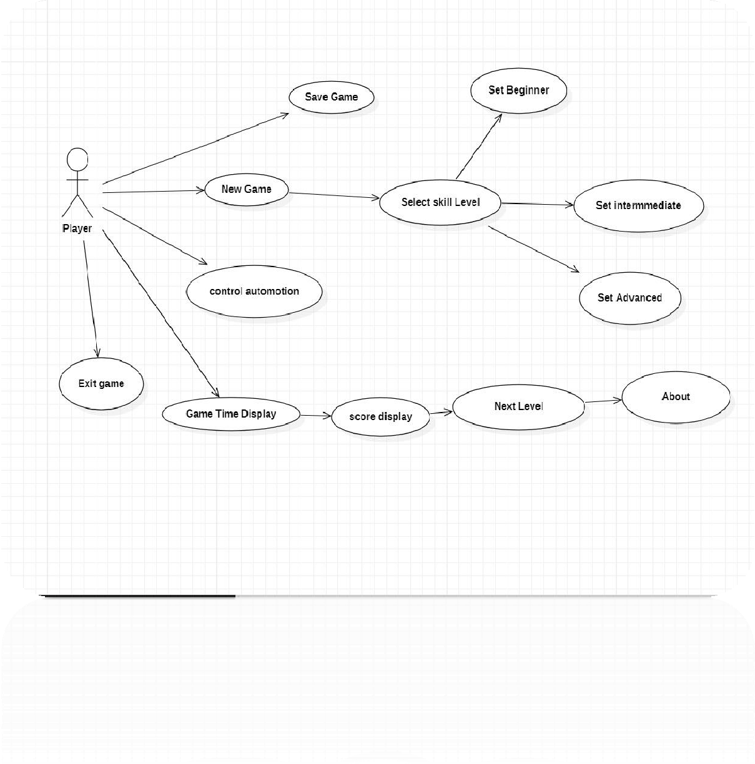

## -:USECASE DIAGRAM:-

-:CLASS DIAGRAM :-

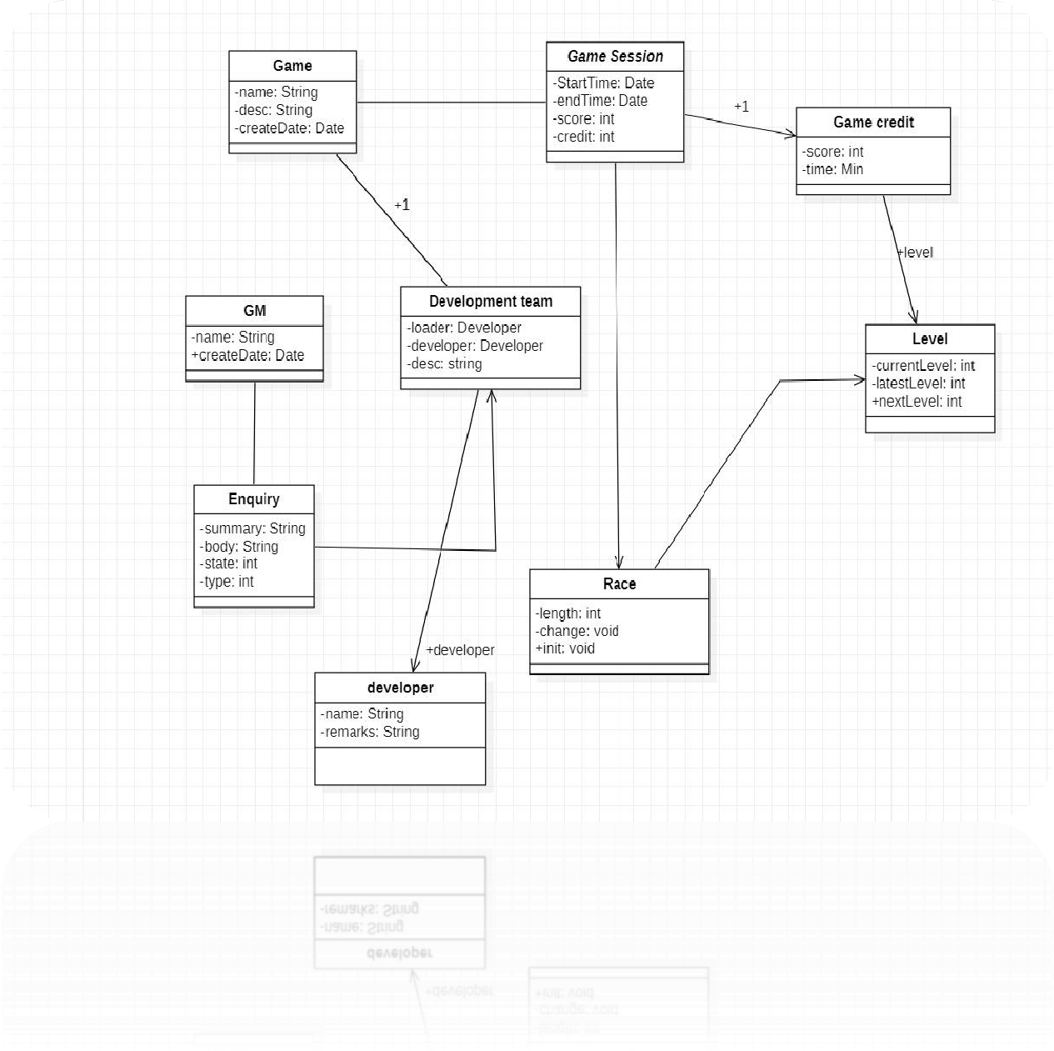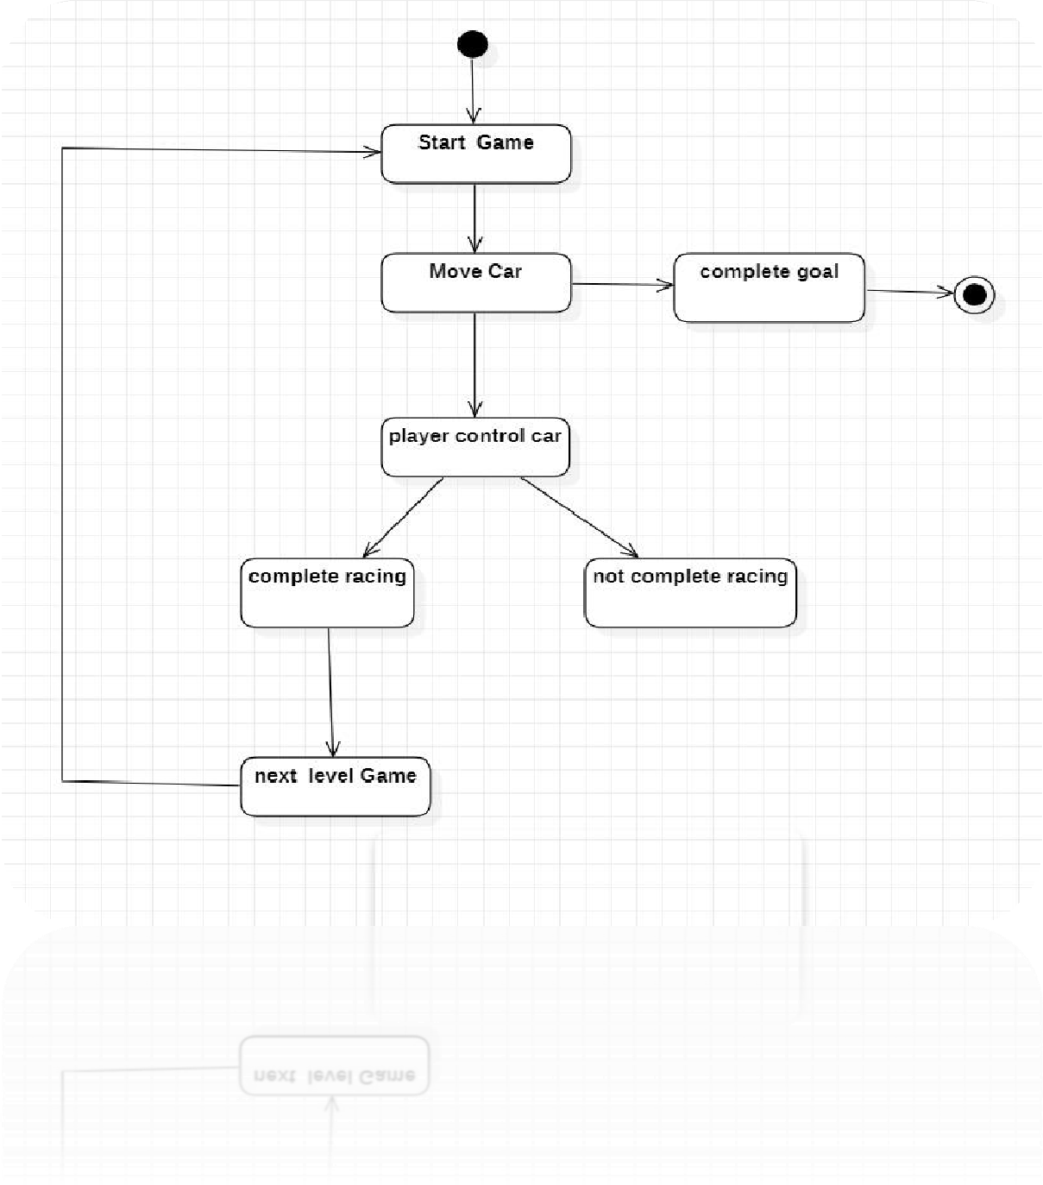

-:ACTIVITY DIAGRAM:-

# Screenshots



#### -:SCREEN SHOTS AND USER MANUAL:-

* The system must be user friendly and user interface is the key point of success of system. How the user can interact with system depends on features and design of the system.
* .Net technology provides us rich GUI, so here we had designed all pages with Visual Basic.net controls.
* The points that we have to keep in mind are:
* Design of all forms with system must follow some sort of uniform method. e. g. Font size of form must be same in all forms. Command button and text box should have same size as possible.
  + Color is center of attraction but while designing the real management system, the color of almost form must be light and same.
  + Size of form and sequence of forms cannot be ignored.
  + Minimum action should reflect optimum output.
  + Since message box and tool tip text provide user friendly environment, so they are suggested.
  + Complexity must be less.

**Some special type of input data format should be specified if required**

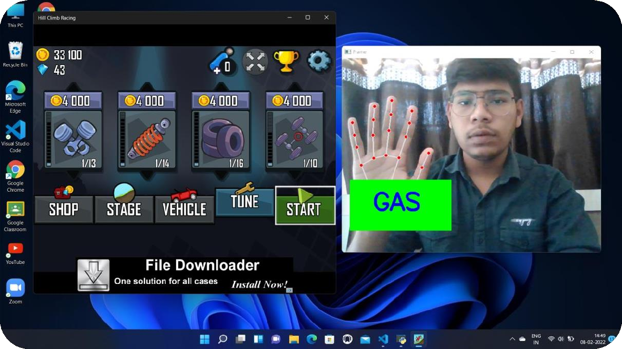

**HOME PAGE :-**

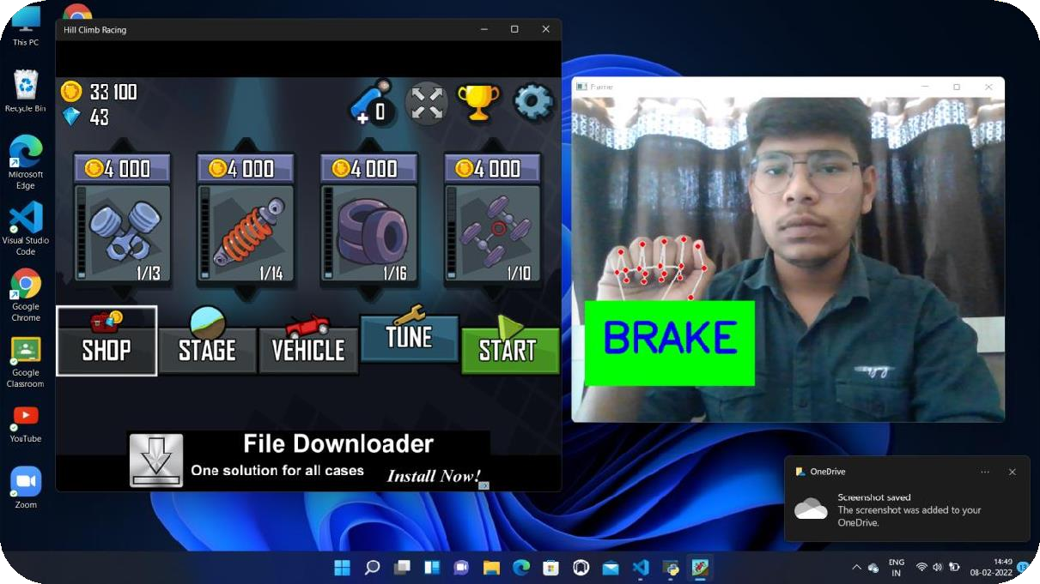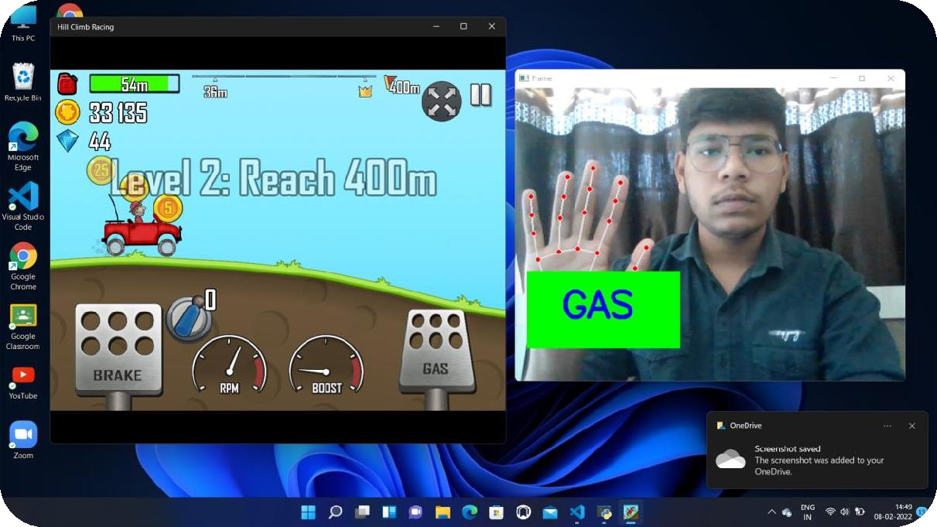

**WATCH SCREEN** :-

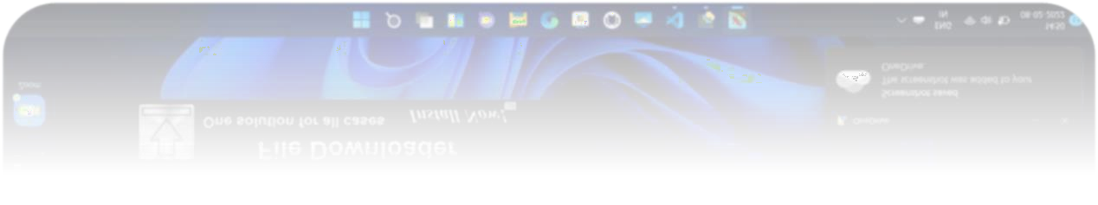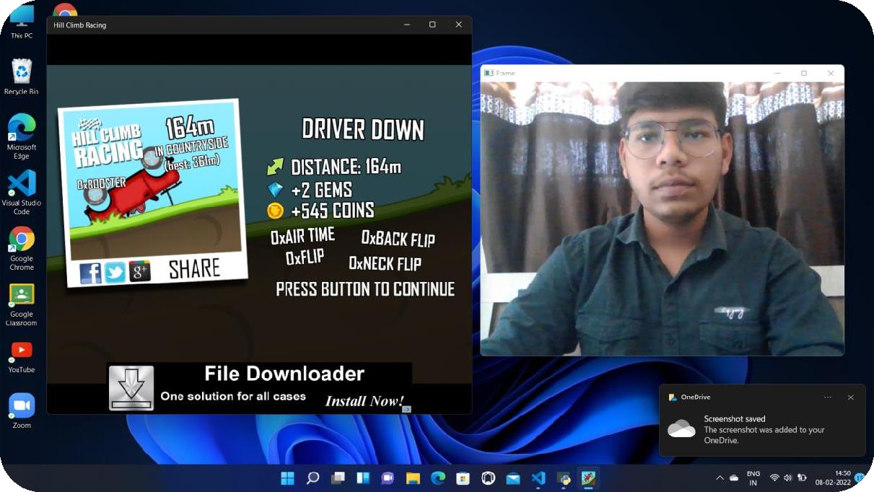

# Conclusion

* **Advantages**
* **Limitations**
  + - **Future Expansions**
      * **Conclusions**



#### -:ADVANTAGES OF THE PROJECT:-

* Supports all Operating Systems.
* Lightweight web application & No personal data is collected.
* User friendly and responsive UI.
* Enjoy the game without any add interruption.

#### -:LIMITATIONS OF THE PROJECT:-

* A hill-climbing algorithm which never makes a move towards a lower value guaranteed to be incomplete because it can get stuck on a local maximum. And if algorithm applies a random walk, by moving a successor, then it may complete but not efficient.

#### -:CONCLUSIONS:-

* + Hill Climb Racing follows the story of an aspiring uphill racer, Newton Bill. This is a physics-based driving game where you help Newton drive up and down a hill while collecting coins and fuel tanks
  + Hill Climb Racing is indeed infinite - there is no end goal or finish line. Instead, it is a game based purely on high score.

# 7. Bibliography

#### -:WEBSITES:-

* + - [www.google.com](http://www.google.com/)
    - [www.javatpoint.com](http://www.codeproject.com/)
    - [www.geeksforgeeks.com](http://www.vbcity.com/)
    - <https://youtu.be/ZBtk3GmJMTE>